MONTREAL’S 3RD
IASD REGIONAL CONFERENCE
April 13, 2013

A DAY FOR DREAMING
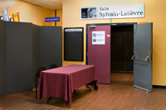 |  | The Colloque was held in Auditorium Sylvain Lelièvre of  Collège de Maisonneuve  conveniently located near two metro stations and major bus lines | 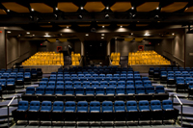
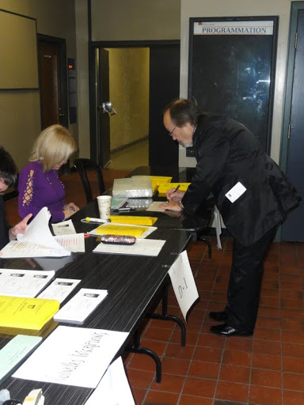 | 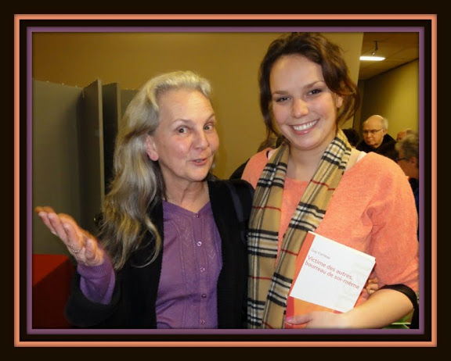 | 377 participants  registered for the Colloque | 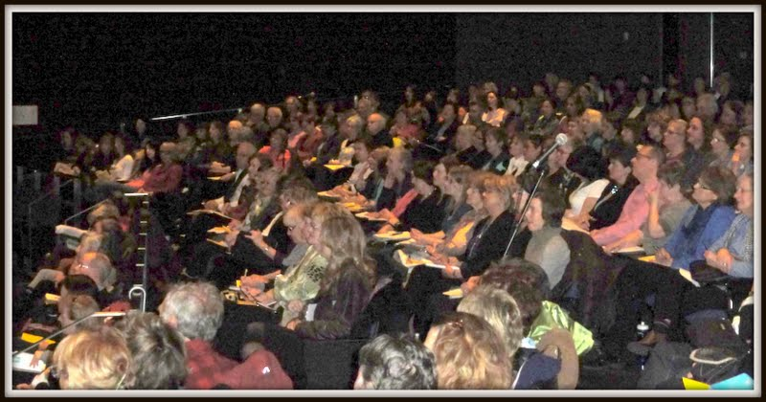
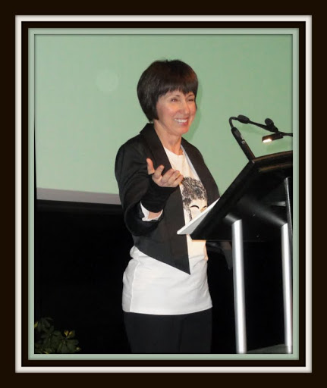 |  | MC, Angela Dupont, invited attendees to imagine they had boarded a train about to leave for dreamland. During the journey eleven presenters would guide them through a variety of dreamscapes, inviting them to ... | 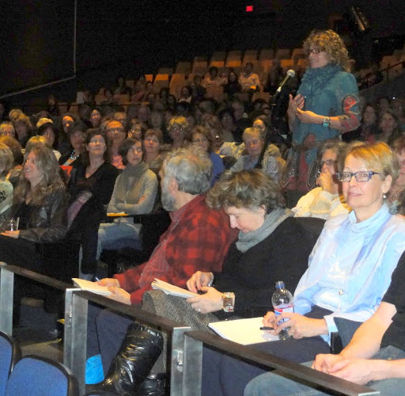
...listen to their dreams in order to :
 |  | live life’s adventure more fully  From Dream to Reality  Manon Lévesque | 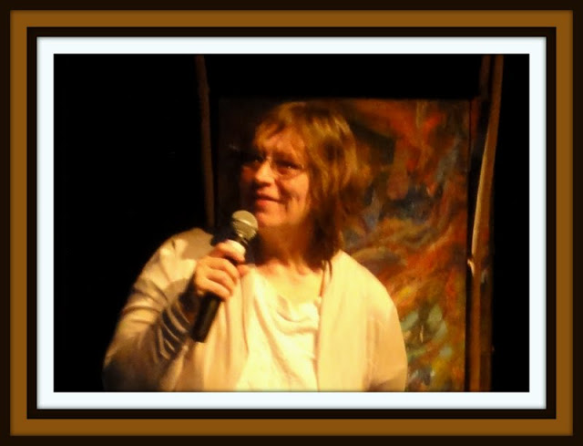
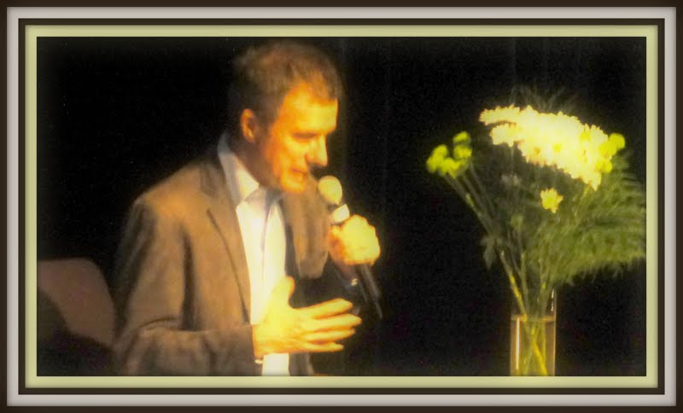 |  | learn from illness (stage IV cancer) to unearth the contradictions between the waking ego’ will and the aspirations of the unconscious  Dreams and Healing  Guy Corneau
 |  | accompany dying persons  and their relatives  Listening to a dying person’s dreams  Monique Séguin | 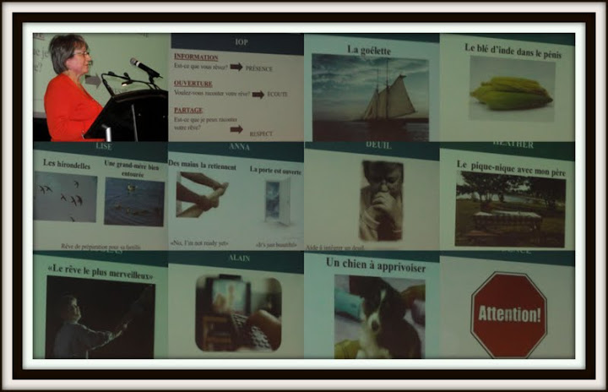
 |  | ... understand their dreams
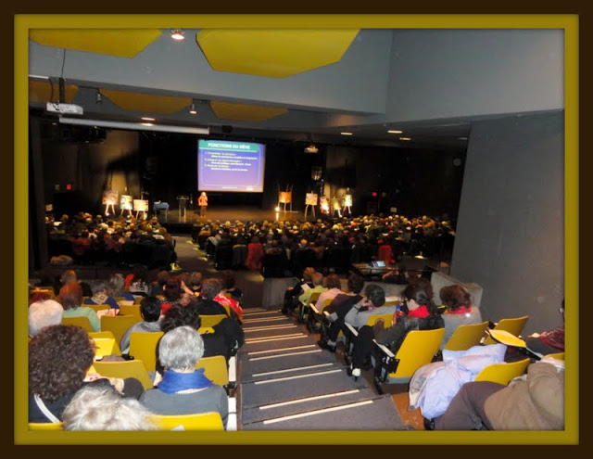 |  | Simple tools to understand your personal symbolism  How to Decode Your Dreams  Nicole Gratton | 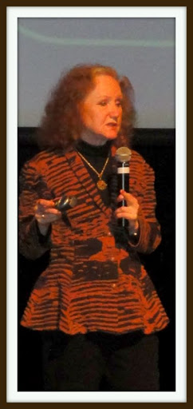
 |  | Personal examples of  Compensatory, Precognitive, Telepathic and Spiritual  Dreams  Denise Cardinal,  Yves Dubuc, Claude Couture | 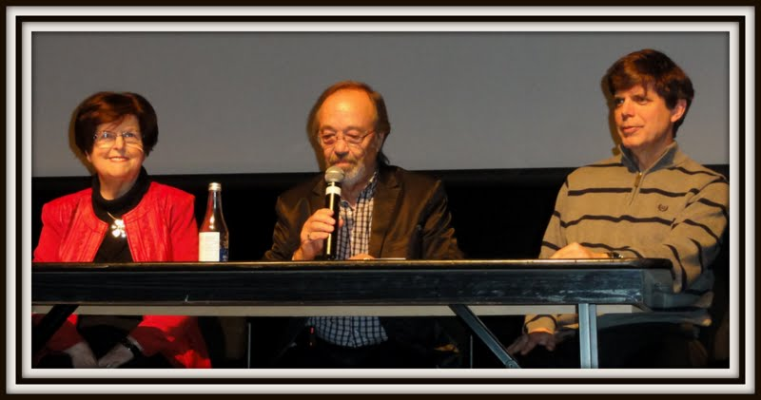
... expand the horizons of dreaming

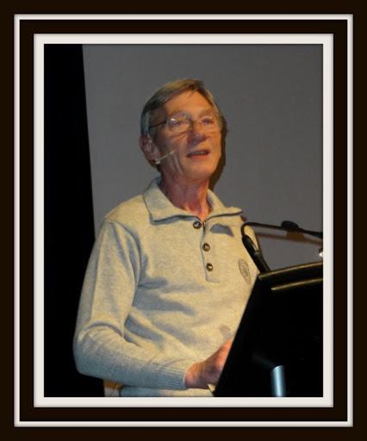 |  | A guided tour of dream incubation traditions around the world  Dream Incubation  Yesterday and Today  Claude Desloges
 |  | Lucid dreaming, inner freedom and expansion of the self  Lucid Dreaming  Louise Marchand | 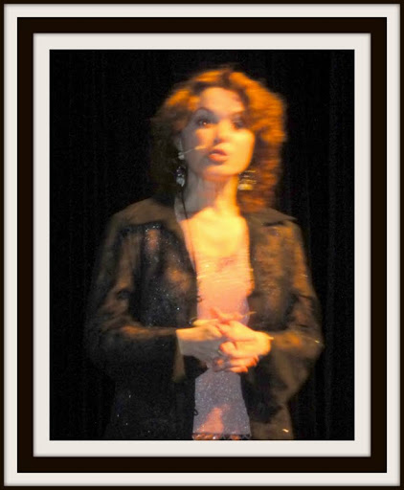

... explore the scientific foundations of dreaming

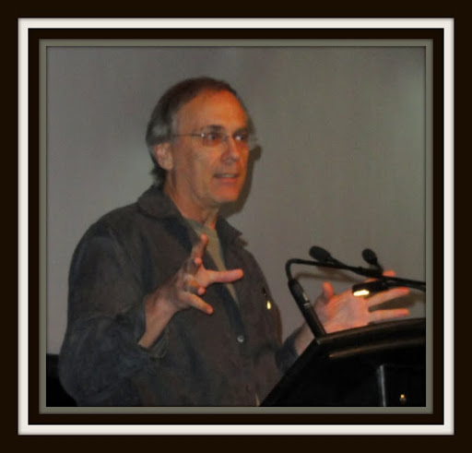 | The reflexions of a researcher on current research on sleep and dream  Why We Dream?  Tore Nielsen
 | Our inner life translates into metaphors at night  and also during daytime  Metaphors at the Heart of Dreaming  Marie-Hélène Maltais | 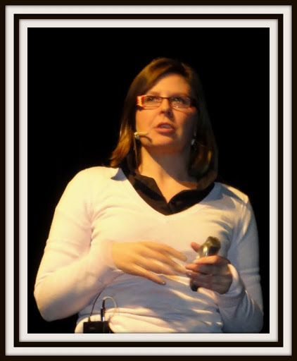
 | ... dream to create beauty
 | Kim Vergil’s artwork provided a stage décor  with a touch of color and magic | 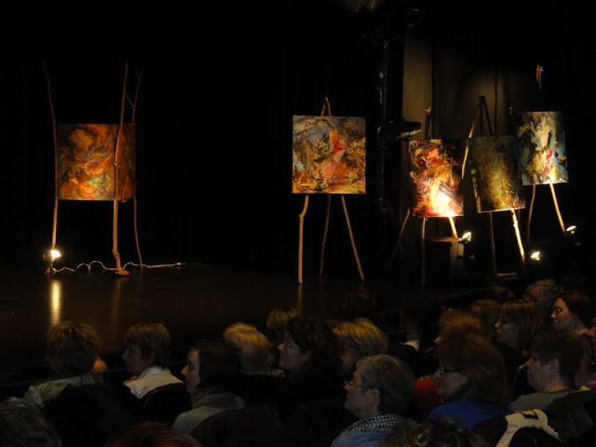
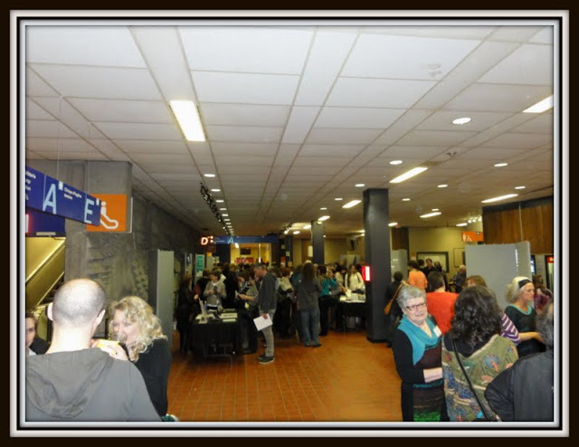 | The vast foyer between the auditorium and the cafeteria  provided ample space  where stands had been set up  to facilitate dialogue  between participants and presenters | 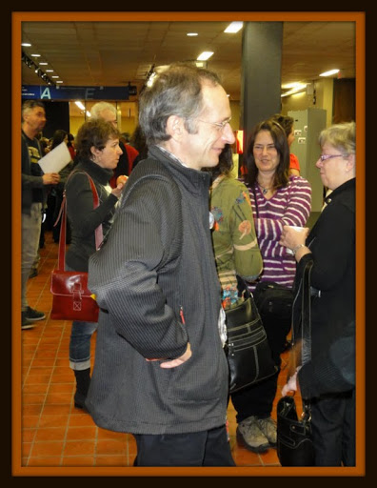
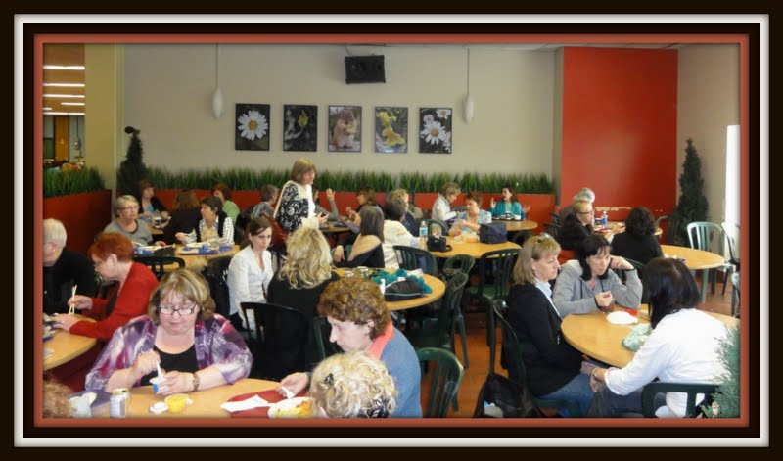 | The cafeteria was conveniently located just a few steps away from the auditorium

 | The Colloque was organized ...
 | with the support of many volunteers, particularly Thérèse Roy,  Carmen Dupont and Nicole Dion | 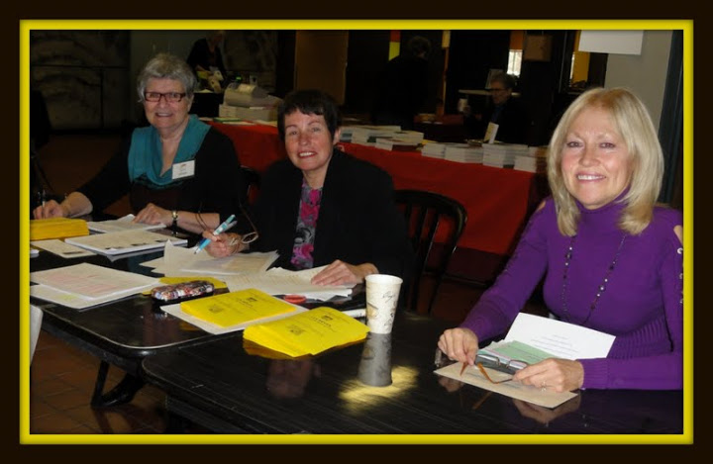
in collaboration with
L’Arc-en-ciel – Centre de réalisation de soi
and
L’École Internationale de Rêves
Nicole Gratton
Merci
The Organizing Committee
 | 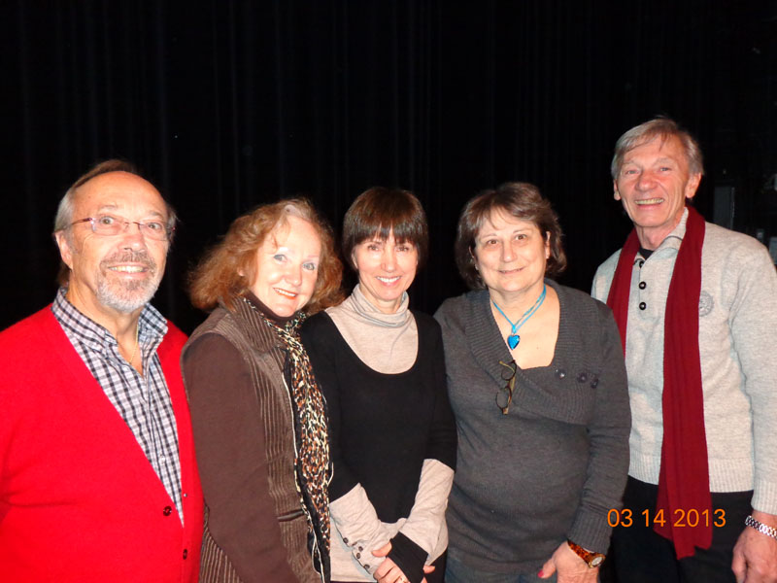
Yves Dubuc, Nicole Gratton,
Angela Dupont, Monique Séguin, Claude Desloges

More photos :
http://picasaweb.google.com/102187505805396332459/IASD2013?authkey=Gv1sRgCNDHyYe3pdemUw&feat=email

